**Evolution of Antibiotic Resistance**

A Report

**By Ahmet VARIS, BSc**

Co-founder and UI/UX designer of colleaguehub.com, 3rd year student at EMU

**Introduction**

Antibiotics were investigated for saving lives from microbial diseases. But as a result of evolution they have to be fit to nature to stay alive. So resistance genes started to be acquired by bacteria which have not resistant to antibiotics. Researches show that these resistance can be caused from horizontal gene transfer or some spontaneous mutations. Nowadays databases and artificial evolution used for estimation for future of evolution of antibiotic resistance.

**How Resistance Evolution Started**

The world is evolving every moment. The evolutions may result of natural effects or artificial effects. Antibiotics which are using as drug, are a part of artificial evolution.First antibiotic had been discovered, just before a few years than first event about antibiotic resistance (4). In 1928 penicillin was discovered by Alexander Flemings. But at 1940 which after years from penicillin published and started to be used by as pharmaceutical drug, penicillinase was discovered by the members of penicillin team (9). In 1994 an antibiotic, called streptomycin, used to treat tuberculosis. But the evolution has come to Mycobacterium *tuberculosis.* Mutant version of this bacteria have resistance to therapeutic concentration of streptomycin (8).

Question is, where these bacteria get resistant genes. The most important part of this evolution arisen from Horizontal Gene Transfer (HGT is a process that the transfer of genetic material without reproduction). Origin of antibiotic resistance which is result of HGT may come from non-pathogenic bacteria or some antibiotics are produced from bacteria, it is understood that the bacteria have resistance to that antibiotics (5). These type of resistance actually had been used by bacteria, before discovery of antibiotics. So resistant genes exist in nature.

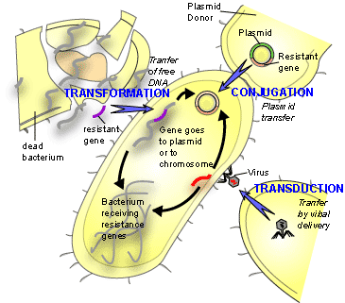

Figure 1: How HGT work. Transformation: free DNA parts taken by bacteria and these make bacterial plasmid. One of these free parts can have resistance gene. Transduction: A bacterial virus bind to bacteria and give its genetic material which consist resistance genes and it turns to plasmid for bacteria. Conjugation: A bacterium give another one it’s plasmid which already have resistance genes.

“This situation implies the existence of three different landscapes important in the evolution of resistance” (The role of natural environments in the evolution of resistance traits in pathogenic bacteria, Jose L. Martinez, 2009);

First level is microbiosphere where all micro-organisms have interactions between each other. Nature has its own antibiotics so micro-organism try to be fit against these antibiotics with interacting to others which have resistance gene. This communication may about their live-dead decision. And also this level is starting point of whole evolution (5).Second level is microbiosphere where touch to human. This may be soil, activated sludge, human gut, and oral microbiomes etc. It is important to understand relation between human and environment to show how human pathogens acquire antibiotic resistance genes (3). Third level is treated patient. At this level commensalism is important. Because pathogens get resistance genes from bacteria which patients have.

Other way of getting resistance is spontaneous mutations. This is Darwinian evolution driven by natural selection which is that wild types are killing by antibiotics and mutant ones live. The mutant genes pass through the next generations with vertical gene transfer. The rate for this type of mutations is 10-8- 10-9. For example at E.coli it is estimated that the streptomycin resistance frequency is 10-9 while using high concentration of antibiotics (11).

**Where Are We Now**